**PIZZA SALES SQL QUERIES DOCUMENTATION**

**KPIs**

1. Total Revenue

select SUM (total_price) AS Total_revenue from pizza_sales

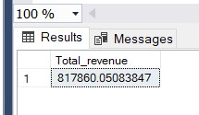

1. Average Order Value

select * from pizza_sales

select sum (total_price)/ count (distinct order_id) as Average_Order_Value from [pizza_sales]

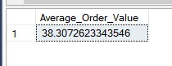

1. Total Pizza Sold

select * from pizza_sales

select sum(quantity) as Total_Pizza_Sold from pizza_sales

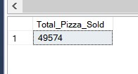

1. Total Orders

select * from pizza_sales

select count(distinct (order_id)) as Total_Orders from pizza_sales

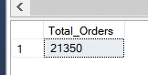

5)Avg Pizzas per order

select * from pizza_sales

SELECT CAST(CAST(sum(quantity) AS DECIMAL(10,3)) /

CAST(count(distinct (order_id)) AS DECIMAL(10,3)) AS DECIMAL(10,3))

AS Avg_Pizzas_per_order

FROM pizza_sales

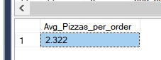

**CHART REQUIREMENTS**

1. Daily trend for total order

select * from pizza_sales

SELECT Datename (DW, order_date) AS Order_day,

Count(distinct (order_id)) AS Total_Order

FROM pizza_sales

group by datename(DW, order_date)

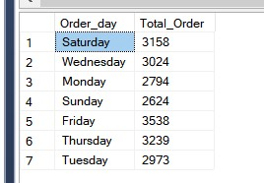

1. Monthly trend for total order

select * from pizza_sales

SELECT Datename (MONTH, order_date) AS Order_month,

Count(distinct (order_id)) AS Total_Order

FROM pizza_sales

group by datename(MONTH, order_date)

ORDER BY Total_Order desc

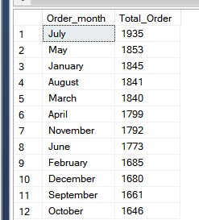

1. Percentage of sales by pizza category

select * from pizza_sales

SELECT pizza_category,

CAST(sum(total_price) AS decimal (10,2)) as total_revenue,

CAST(sum(total_price) * 100 / (SELECT sum(total_price) from pizza_sales) AS decimal (10,2)) AS percentage_by_category

FROM pizza_sales

group by pizza_category

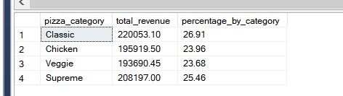

1. Percentage of sales by pizza size

select * from pizza_sales

SELECT pizza_size,

CAST(sum(total_price) AS decimal (10,2)) as total_revenue,

CAST(sum(total_price) * 100 / (SELECT sum(total_price) from pizza_sales) AS decimal (10,2)) AS percentage_by_size

FROM pizza_sales

group by pizza_size

order by total_revenue

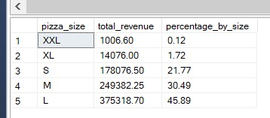

1. Total Pizza Sold By Category

select * from pizza_sales

SELECT pizza_category,

sum(quantity) as total_quantity,

CAST(sum(quantity) * 100 / (SELECT sum(quantity) from pizza_sales) AS decimal (10,2)) AS percentage_by_unit_size

FROM pizza_sales

group by pizza_category

order by total_quantity

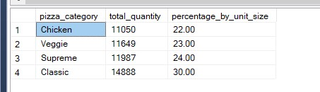

1. Top 5 pizza places by revenue

select * from pizza_sales

select top 5 pizza_name, sum(total_price) as total_revenue from pizza_sales

group by pizza_name

order by Total_Revenue desc

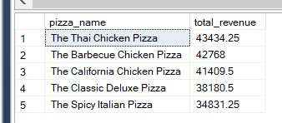

1. Bottom 5 pizza places by revenue

select * from pizza_sales

select top 5 pizza_name, sum(total_price) as total_revenue from pizza_sales

group by pizza_name

order by Total_Revenue

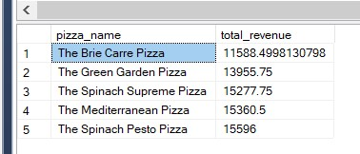

1. Top 5 pizza places by quantity

select * from pizza_sales

select top 5 pizza_name, SUM(quantity) as total_pizza_sold

from pizza_sales

group by pizza_name

order by total_pizza_sold desc

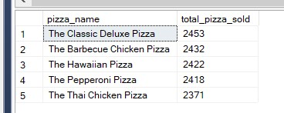

1. Bottom 5 pizza places by quantity

select * from pizza_sales

select top 5 pizza_name, SUM(quantity) as total_pizza_sold

from pizza_sales

group by pizza_name

order by total_pizza_sold

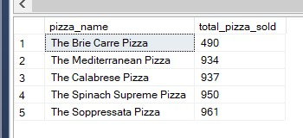

1. Top 5 Pizzas By Total Order

select * from pizza_sales

select top 5 pizza_name, count(distinct (order_id)) as total_pizza_ordered

from pizza_sales

group by pizza_name

order by total_pizza_ordered desc

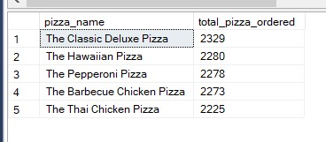

1. Bottom 5 Pizzas By Total Order

select * from pizza_sales

select top 5 pizza_name, count(distinct (order_id)) as total_pizza_ordered

from pizza_sales

group by pizza_name

order by total_pizza_ordered

